**Cool Chard with Peppery Ricotta**   
  
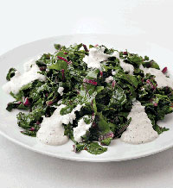SERVES 8 TO 10 MINUTES AS A SIDE DISH

**Ingredients**

* Salt
* 3 pounds white or red Swiss chard, leaves sliced into ½-inch-wide ribbons
* 6 tablespoons extra virgin olive oil
* ¼ cup red wine vinegar
* 1-½ cups fresh ricotta, preferably sheep’s milk ricotta, drained
* ½ teaspoon freshly grated nutmeg
* 3 tablespoons freshly cracked black pepper

**Directions**

1. Bring 8 quarts of water to a boil in a large pasta pot. Set up a large ice bath nearby.When the water comes to a boil, add 2 tablespoons salt. Drop the chard into the water and cook until tender, 7 to 8 minutes.

2. Drain the chard and plunge it into the ice bath. When it has cooled, drain it well. Place the chard between two platters and press them together very firmly to release the excess water. Place the chard in a large mixing bowl, add the oil and vinegar, and toss. Season lightly with salt, and set in a cool place or in the fridge.

3. Mix the ricotta, nutmeg, and black pepper in a bowl until well blended. Set aside.

4. When ready to serve, arrange the chard on a wide, flat platter and spoon 10 to 12 small dollops of the ricotta around it. Serve cool.